Українсько-турецький бізнес-форум
Ukrayna-Türkiye İş Forum
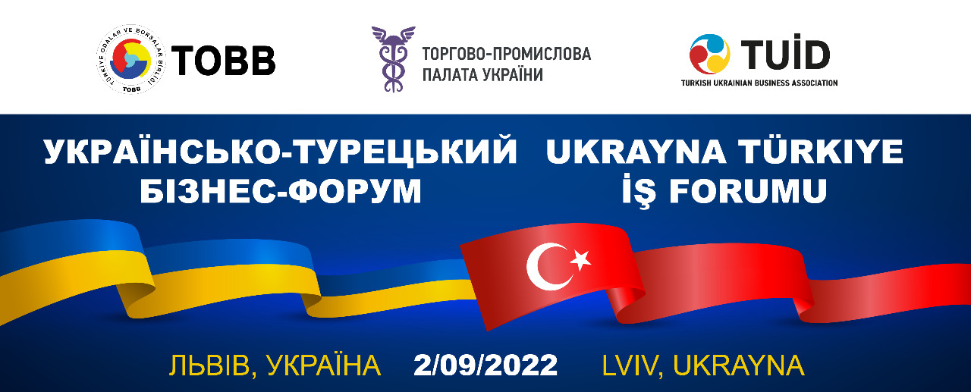

PROGRAM
Venue: Grand Hotel, Lviv, with online connection
Working languages: Ukrainian / Turkish
10:00-11:30 | REGISTRATION
11:30-12:30 | OPENING SESSIONS
 | Moderator: representative of UCCI
 | Mr. Gennadiy Chyzhykov | President of the UCCI
 | Mr. Rifat Hisarciklioğlu | PRESIDENT OF TOBB
 | Mr. Yağmur Ahmet Güldere | Ambassador Extraordinary and Plenipotentiary of Turkey to Ukraine
 | Mr. Mustafa Naiem | Deputy Minister of Infrastructure of Ukraine
 | Mr. Oleksandr Bornyakov , | Deputy Minister of Digital Transformation of Ukraine
 | Mr. Burak Pehlivan | President of the TUİD
 | Mr. Andrii Sadovyi | Head of Lviv city
 | Mr Andrii Hodyk | Deputy Head of Lviv Regional Administration
 | Mr. Serhii Nizhynskyi | Advisor to the Vice Prime Minister on European and Euro-Atlantic integration, Deputy Minister of Social Policy 2019-2020, Co-author of the Export Strategy of Ukraine
 | representative | Ministry of Economy of Ukraine
 | representative | Ministry for Foreign Affairs of Ukraine
 | representative | Ministry of Agrarian Policy and Food of Ukraine
 | representative | turkish delegation
 | Closing remarks of organizers
12:30-14:00 | B2B/ Coffee break

